Sangala Mosaic User Guide
Sangala Mosaic is the Mosaic Design Tool you use to turn a photograph into a LEGO-tile mosaic you build by hand on a baseplate. You have chosen an animal — a crested crane, a buffalo, whatever is yours — and you have a picture of it. This guide takes you from that picture to a finished plan: the tiles laid out square by square, in the colors of your Tile Palette, with a parts list telling you how many of each to gather.
Everything runs in the browser. There is no install, no internet, and no machine to connect to — the mosaic is built by hand, so the tool's whole job is to hand you a plan you can follow.

1. The big picture
Every mosaic follows the same path:
Open a photo → frame the part you want → Build It! → tidy it by hand → read off the parts list.
The one idea that turns this from a toy into a build tool: Sangala maps your picture to the colors in your Tile Palette, and then tells you how many of each you will need — and the palette can be anything: the standard set, the tiles you have, or the tiles you plan to get. That idea runs through the whole guide — Section 3 is the one to read closely.

2. The screen
Sangala Mosaic has four regions, like a workbench:
- Menu bar (top) — Open a photo or a saved project, Save your work, Print the mosaic, Settings (the gear — opens Setup: the grid and the baseplate), and ways of looking at it: Transparent and About.
- Tools (left edge) — Select picks things up; Paint, Pick, and Erase edit cells by hand after building; Tiles and Wand select tiles for grouping into masses (Section 11).
- The workspace (center) — your working surface. Your photo (or photos) and the grid frame sit here; this is where you arrange what will become the mosaic.
- Build panel (right) — the green Build It! button and everything that shapes the result: the Adjust Mosaic controls, your masses, and the Palette. The grid and the baseplate live in Setup, behind Settings.
You never connect to anything — open a photo and you can start.

3. The Tile Palette (read this)
This is the heart of the tool. The mosaic is built from the colors in the Tile Palette, and the parts list counts how many of each the design needs.
- The palette drives the mosaic. Down the right side is the Palette — real LEGO tile colors, including several grays from very light to dark, so a mostly-gray subject still shows its shading. The mosaic uses only these colors. To change them, press Tile Colors and then Edit: click a color to turn it off or back on. Clear empties the palette so you can add just the colors you want; Reset brings back the standard set.
- Add colors from a photo. Add Tile Colors in a Photo (under Tile Colors) reads the LEGO colors out of a photo in the workspace — loose tiles, a tray of them, or a mosaic already built — and adds them to the palette as My Tiles, kept beside the Standard Tiles.
- The parts list counts the tiles. After you build, the status line totals them, and Save → Tile List writes every color with its count — “47 dark gray, 23 white, 8 red…” — the list to order from or build against. The printed sheet carries the same counts beneath the picture.
Set the palette to fit your plan — the standard set, the tiles you have, or the tiles you will get. Everything else in this guide serves this one idea.

4. Open a photo (and build a scene)
- Click Open (or drag a picture onto the workspace). Sangala accepts .png and .jpg.
- The photo drops onto the workspace at a comfortable size. Drag its body to move it; drag a corner handle to resize it (the shape is kept, so it never stretches). Press Delete to remove a selected photo.
- Open again to add another picture. Each Open adds a layer, so you can build a scene — mountains behind, your animal in front — and turn the whole composite into one mosaic.
Layer order (which picture is in front). Select a picture to open its panel on the right, then use the layer controls there to send it forward or back, so the foreground animal sits on top of the background.

5. Remove the background
To lift your animal off its background so only the animal becomes tiles:
- Select the picture.
- In its panel, turn on Remove Background. Sangala clears the backdrop from the edges inward and leaves the subject — keeping interior whites (a crane's white belly stays; only the true background goes).
- The original is never lost. Turn Remove Background off to bring the backdrop back.
With the background removed, the empty area around your animal becomes empty cells in the mosaic (or bare baseplate), not tiles — so you don't spend tiles on sky you never wanted.

6. The grid — framing your mosaic
The grid frame is the box on the workspace that decides what becomes the mosaic and how fine it is. Whatever falls inside the frame is what gets built.
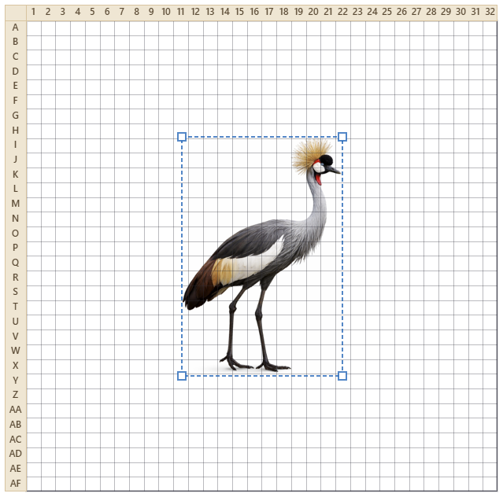
Figure 1. A photo positioned under the grid — whatever falls inside the frame becomes the mosaic.
- Move it — drag the frame's border. Resize it — drag a corner (the cells stay square).
- Fit to Photo — one press lays the grid over the photo for you: the largest area of the grid’s shape that fits the picture. Adjust from there if you want a different framing.
- Across and Down — in the Grid Controls section of Setup (press Settings), set how many tiles wide and tall. The standard baseplate is 32 × 32, and that is the default. The readout shows the real size — 32 × 32 tiles is about 256 mm ≈ 10 inches — so you know how big the finished piece will be.
- Show — three checkboxes for what you see on the workspace: Grid (the cell lines and the row and column labels — numbers across the top, letters down the side — that you follow while building), Baseplate (the studded plate behind the tiles), and Box (the outline around the mosaic). Turn any of them off — turn all three off to see just the mosaic itself.
Fewer tiles across make bigger, blockier tiles and a coarser picture; more make a finer picture that needs more, smaller tiles. Slide the frame over the part of your animal you most want to capture.

7. Build It!
Press the green Build It! button and Sangala maps the framed picture to your palette colors, cell by cell, and shows the result on its baseplate. Transparent lets you check it against the photo.
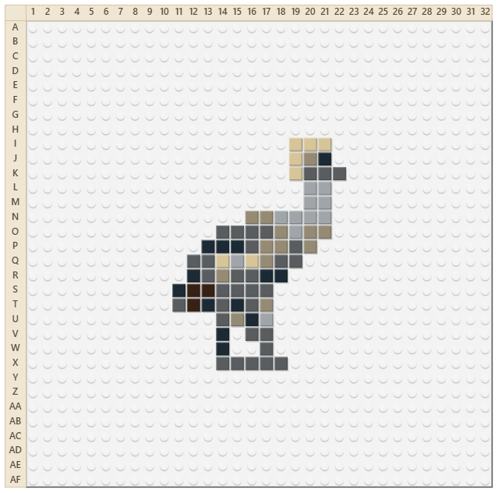
Figure 2. The finished mosaic on its baseplate.
A few controls (in the Adjust Mosaic part of the panel) shape the result; change any one and the mosaic re-maps at once:
- Ignore background (on by default) — treats the removed or empty background as empty cells, so thin parts like legs survive instead of being outvoted by a sea of sky.
- Colors — how many different tile colors to reduce the picture to. A low number gives a bolder, simpler mosaic; a high number gives more shading. Sangala always snaps these to the nearest palette colors.
- Clean up — gently fills single-tile holes and drops lone stray tiles, so the mosaic reads cleanly without erasing real detail.
- Contrast and Brightness — adjust these if the picture is going muddy; a little more contrast separates the colors before they are reduced.
If the result is close but not perfect, that is expected — the last touch-ups are done by hand (Section 10).

8. The baseplate
The built mosaic sits on a baseplate — the studded plate the tiles snap onto — so you see it the way it will really look.
- Baseplate color — choose from the Baseplate swatches in Setup (press Settings). These are limited to the colors LEGO actually sells baseplates in (White, Green, Gray, Blue, Sand, Black, Red, and Light Blue), so your plan stays realistic. White is the default.
- Show or hide — the Baseplate checkbox hides the plate for a clean, chart-like view of just the tiles (handy for reading the pattern). With the plate shown, the studs mark the grid; hide it and the cell lines return so empty cells stay clear.

9. Seeing your work
The mosaic sits in the grid, so it is always on screen. Two ways to check it against the photo:
- Side by side — the workspace stays live, so Open a copy of the photo and drag it beside the mosaic; adding or moving it never disturbs the mosaic.
- Transparent — make the tiles translucent so the photo shows through underneath. Turn this on while painting (Section 10) to trace the picture tile by tile.
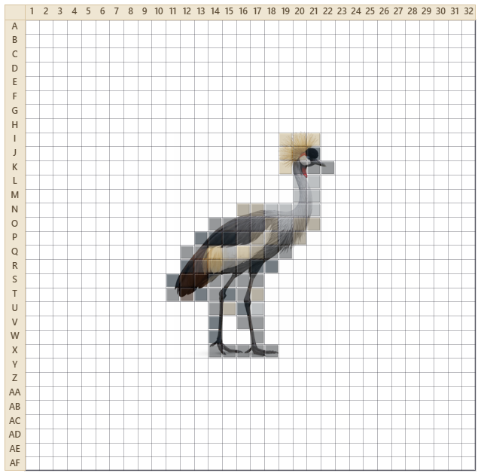
Figure 3. Transparent makes the tiles translucent so the photo shows through.

10. Fixing it by hand: Paint, Pick, Erase
Automatic mapping gets you most of the way; the eye, a beak, a clean edge are placed by hand. After you build, use the tools on the left rail:
- Paint — click a color in the palette, then click or drag across cells to set them to that color. Right-click a cell to clear it.
- Pick — click a cell to grab its color, then keep painting with it.
- Erase — click or drag to clear cells back to empty (the baseplate shows through).
Undo is there. Ctrl-Z undoes your last stroke — a whole dragged line comes back in one press — and Ctrl-Y (or Ctrl-Shift-Z) redoes it. Rebuilding, or changing the photo, starts fresh, so save your hand edits for last.

11. Masses — naming the parts of your animal
A mosaic of an animal is really a mosaic of its parts — the head, a leg, a horn. After you build, select the tiles of a part and Group them into a named mass, so that part can be picked up again and adjusted as one thing.
- Tiles — drag a box to select the tiles inside it, whatever color they are.
- Wand — click a tile to select the whole connected run of that color.
- Shift-click adds or drops a single tile; Alt removes; Ctrl-D deselects. The three selection tools all feed one selection, so mix them freely.
- Group turns the selection into a named mass. Select (the arrow) reselects a mass with one click; change its tiles and the button reads Update Mass — press it to keep the change.
Masses are saved in your project, so the parts of your animal keep their names when you reopen it.

12. The parts list (bill of materials)
After Build It!, the status line gives the headline — how many tiles in how many colors. Save → Tile List writes the full list as a text file: every color with its count, sorted most-used first, and the grand total. Print puts the same counts beneath the picture on the printed sheet (Section 13). This is your gather-and-build list — and because Sangala builds only from the palette, every line is a color in it.

13. Saving and printing your work
Once your mosaic looks the way you want, you can save it to finish later, reopen a saved project, or print it to build away from the computer.
- Save your work — the Save button gives a choice. Project saves everything as a .mosaic file — your photos, the grid, your palette, your masses, and the built mosaic — so you can reopen it later and keep editing, and you choose where it goes. Image saves a picture of the mosaic as a .png or .jpg.Tile List saves the tile counts by color as a .txt — the list to order from or build against.
- Reopen a project — the same Open button that opens a photo also reopens a saved .mosaic project, bringing your whole workspace back so you can carry on.
- Print — the Print button prints the mosaic. The saved picture and the printout both show exactly what the Show checkboxes show, so turn on Grid and you get a build chart with the coordinates — print it and build the mosaic square by square, with no computer needed. Beneath the picture, the printout lists the tile counts by color — the chart and the gather list on one sheet.

14. Quick reference
I want to… | Do this
Add a photo | Open, or drag a picture onto the workspace
Move or resize a photo | Drag its body, or a corner handle
Build a scene | Open more pictures; set which is in front with the layer controls
Drop the background | Select the photo, turn on Remove Background
Choose what becomes the mosaic | Drag or resize the grid frame over it
Fit the grid to the photo | Fit to Photo (in Setup)
Set the mosaic's size | Across and Down in the Grid section
Choose your palette colors | Tile Colors, then Edit — click colors on or off
Make the mosaic | Build It!
Simplify or add shading | The Colors slider
Change the baseplate | Baseplate swatches; uncheck Baseplate to hide it
Save your work | Save → Project (.mosaic), Image (.png / .jpg), or Tile List (.txt)
Print the mosaic (or a build chart) | Print — turn on Grid for coordinates
Compare with the photo | Transparent, or drag the photo beside the mosaic
Fix a cell by hand | Paint, Pick, or Erase; Ctrl-Z to undo
Name a part of your animal | Tiles or Wand to select it, then Group
Get the parts list | Save → Tile List, or the counts on the printed sheet

15. Which tools for which task
- Turning your animal into a mosaic: Open the photo, Remove Background, frame it with the grid, set your palette, Build It!, then finish the face and edges with Paint.
- A scene with a background: Open the background first and the animal second, set the layer order, frame the two together, then Build It! so both become one mosaic.
- Getting a clean likeness: build with a low Colors count for a bold read, turn on Transparent to trace the details, and Paint the eye and beak by hand.
- Working part by part: select a leg or the head with Tiles or Wand, Group it as a named mass, and reselect it any time to adjust that part alone.
- Planning the build: pick your Baseplate color, save the Tile List (or print the sheet) for what to gather, and follow the numbered and lettered grid square by square.

